Course Project - Write ETL Job and Migrate data into the Database

Shaun Pritchard

Rasmussen College

QMB4200

Terry Brookhouser

October 22, 2020

Course Project - Write ETL Job and Migrate data into the Database

I initially tried loading all the data columns. I ran into issues based off my character lengths allocation and other errors as posted below. I did successfully append 3 columns of data.

Here are the errors I ran into:

***TITLE: Package Validation Error ------------------------------ Package Validation Error ------------------------------ ADDITIONAL INFORMATION: Error at Data Flow Task [OLE DB Destination [600]]: The number of input columns for OLE DB Destination.Inputs[OLE DB Destination Input] cannot be zero. Error at Data Flow Task [SSIS.Pipeline]: "OLE DB Destination" failed validation and returned validation status "VS_ISBROKEN". Error at Data Flow Task [SSIS.Pipeline]: One or more component failed validation. Error at Data Flow Task: There were errors during task validation. (Microsoft.DataTransformationServices.VsIntegration) ------------------------------ BUTTONS: OK ------------------------------***

Second error I had:

***Message: SSIS Warning Code DTS_W_MAXIMUMERRORCOUNTREACHED. The Execution method***

***succeeded, but the number of errors raised (1) reached the maximum allowed (1); resulting in failure.***

***This occurs when the number of errors reaches the number specified in MaximumErrorCount.***

***Change the MaximumErrorCount or fix the errors.***

So, I restarted bot SQL studio and Visual studios and I got it to work. It seems every time I try to update my database tables, but I would refresh the object Explorer the old table was still there. I had to restart the entire program empty out the cache.

**SSIS Packages**

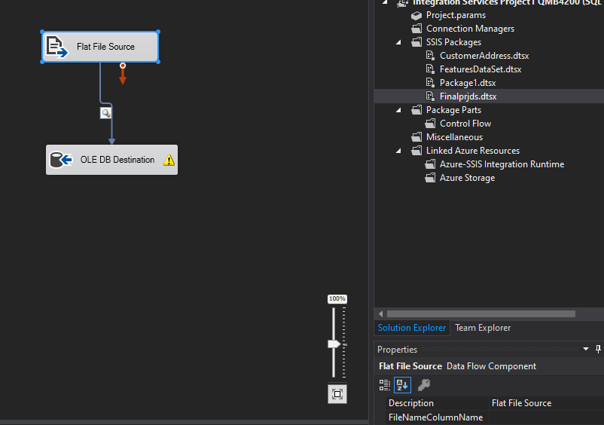

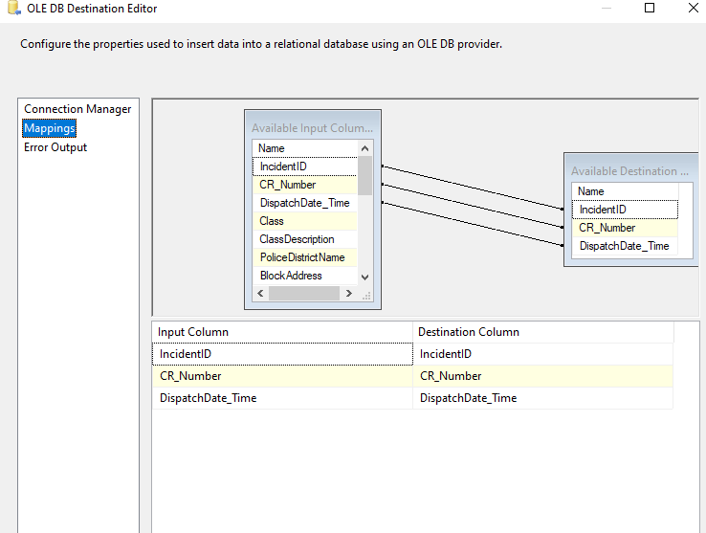

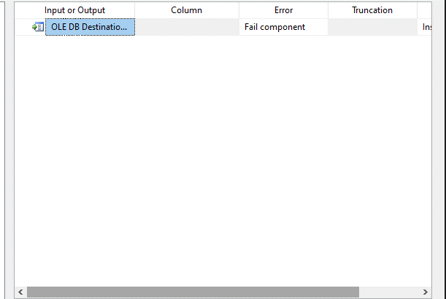

**SQL Table queries:**

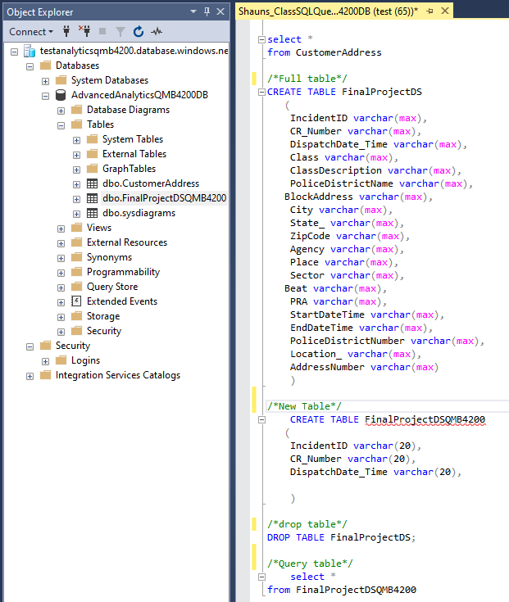

**Data results:**

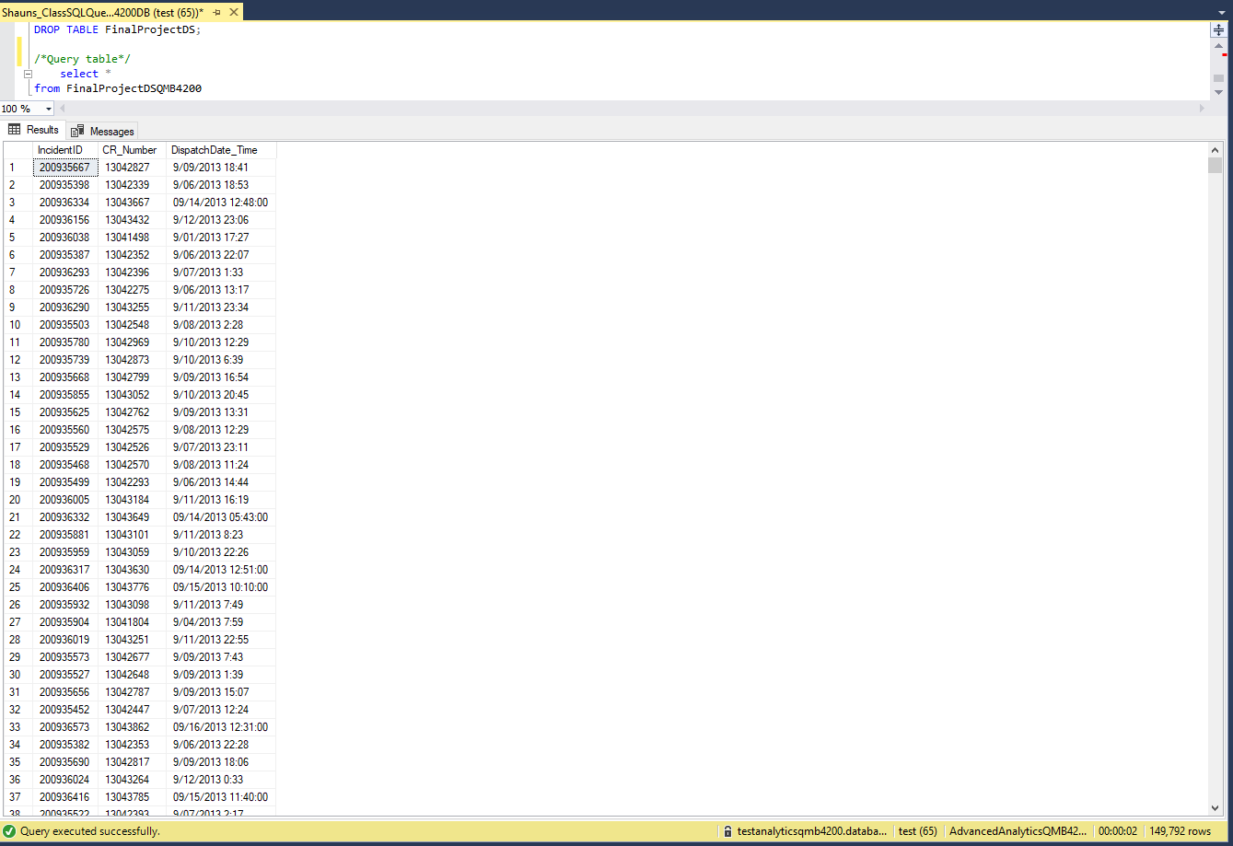

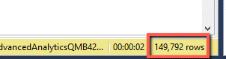

**Execution results:**

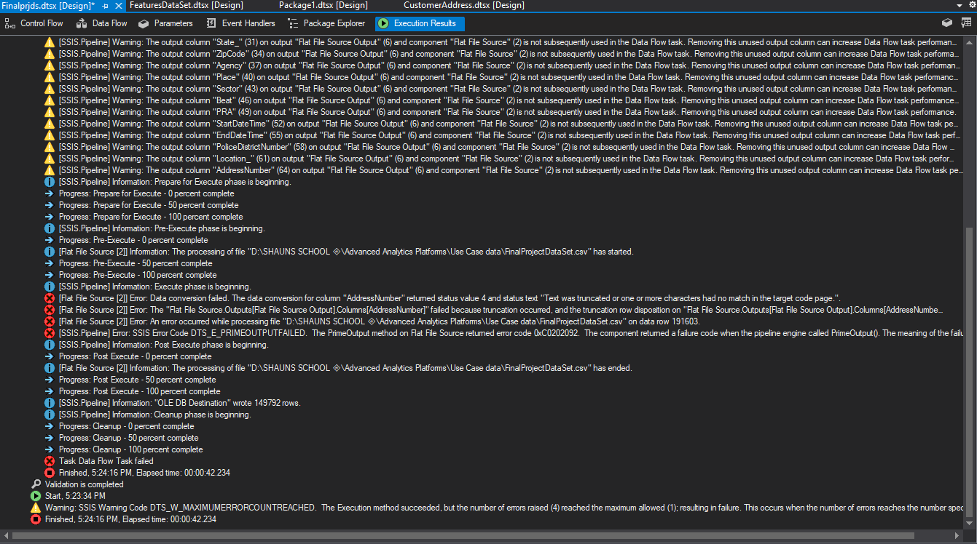

Note:

I did however try to resolve some of the issues by looking up the error codes I was really stumped by the maximum error count reach. Then I can find is that the table name I was creating maybe it conflicted with what I was needing my SSIS package?

But I was aware that there was a lot of inaccurate data in the final data project there is chunks of missing data there was Data with symbolic characters, more than 50 characters, and several other things I noticed.

1. Are we supposed to uncheck all the available external columns from The Source assistant that we are not using before we connect it to the source?
2. In order to Output columns of the table that we built correctly how do we handle Error output on the destination?
3. What is the maximum error count?